Internal Auditing & Monitoring Work Plan
CY 2019

TABLE OF CONTENTS

SCOPE 3
DEFINITIONS 3
AUDIT ACTIVITIES 4
Internal Controls Over Financial Reporting 4
Medicare Compliance 7
Commercial / ACA Compliance 11
Commercial / URAC Accreditation Compliance 13
MONITORING ACTIVITIES 15
PROCESS OWNER ATTESTATION 19
DOCUMENTATION & REPORTING 20
Audit Activities 20
Monitoring Activities 20

SCOPE
The internal auditing and monitoring work plan includes internal control testing, internal audit activities, and departmental monitoring activities. Internal auditing and monitoring activities may also include oversight of delegated entities (e.g., Pharmacy Benefit Manager) and activities related to fraud, waste and abuse.
Internal Audit (IA) uses a risk-based approach to develop the annual schedule of internal audit activities which includes processes and procedures related to financial reporting and regulatory compliance for health plans administered by X Organization HMO, Inc.
Monitoring activities are scheduled by each responsible department and are specific to compliance with Medicare requirements administered by X Organization HMO, Inc.

DEFINITIONS
Internal Control Testing – an audit procedure used to confirm whether components of internal control exist and are functioning as intended. For internal controls over financial reporting, testing is conducted to determine whether controls are likely to prevent or detect a material misstatement in the financial statements. For internal controls over compliance, testing may be conducted to determine whether controls are likely to prevent or detect an instance of non-compliance with applicable rules and regulations.
Internal Auditing – a formal review conducted by the Internal Audit (IA) department to confirm compliance with a particular set of standards (i.e., regulations, policies, procedures, etc.).
Internal Monitoring – activities performed as part of a department’s normal operations to confirm ongoing regulatory compliance and to ensure actions taken to correct and/or prevent issues are effective.
First-Tier, Downstream and Related Entity (FDRE) Auditing & Monitoring – activities undertaken by X Organization to confirm that functions delegated to its FDREs are performed in a manner consistent with regulatory requirements, and that corrective actions by the FDRE are sufficient and effective.
Fraud Waste & Abuse (FWA) Monitoring – activities performed to identify and remediate potential fraud, waste or abuse, as defined by CMS, that affects health plans administered by X Organization or the health care system as a whole.

AUDIT ACTIVITIES
Scope
Internal audit activities performed by the Internal Audit department include:
- Internal controls over financial reporting (ICOFR)
- Internal controls over compliance
- Compliance with Affordable Care Act rules and regulations
- Compliance with Medicare rules and regulations
- Compliance with URAC accreditation standards

Sampling Method
To the extent practicable, audit activities will be performed using a random sampling method designed to obtain an unbiased selection. Alternate sampling methods (i.e., targeted, stratified, weighted) may also be used, if necessary, to obtain a more representative sample. The universe of data from which samples are drawn will be related to the period that is the subject of the audit, or be sufficiently close in time to ensure that audit results can be applied rationally to the universe. If the universe related to a particular element or requirement is of insufficient size to permit random sampling, the entire universe will be audited. Additionally, the sample size may be increased to determine the member and/or financial impact when a potentially systemic issue is identified.

Internal Controls Over Financial Reporting
The work plan for testing internal controls over financial reporting covers all applicable insurance companies. However, per Model Audit Rule (MAR) requirements set forth by the National Association of Insurance Commissioners (NAIC), only X Organization HMO is currently required to file management’s report on key internal controls due to its amount of direct written premiums. The MAR program involves both an evaluation (i.e., attestation) by process owners and an independent validation test by IA. These two activities are conducted to provide reasonable assurance to senior management and the board of directors that internal controls are operating as intended in order to prevent or detect, in a timely manner, a material misstatement or omission in the financial statements.

Risk Assessment
During phase II of the 2018 MAR Optimization project, Finance conducted a risk assessment of each financial statement line item (FSLI) from the 2017 calendar year. The exercise involved an assessment of each item’s quantitative significance along with certain qualitative risk factors to determine the risk of misstatement and related financial statement assertions (e.g., completeness, valuation, etc.). Based on results of the risk assessment, external consultants with KPMG identified the following optimization opportunities for controls related to seven of the twelve key processes:

- Reduction Opportunities (i.e., key to non-key) – 13 controls were identified as non-key rather than key based on an indirect financial statement impact or its associated risk covered by another key control.
- Consolidation Opportunities - 18 instances where multiple controls were addressing the same key risks; therefore, an opportunity to consolidate into one or two key controls (e.g., system access and segregation of duties) was identified.
- Potential Additions - 2 controls that were previously deemed as non-key were identified as possibly addressing key risks.

Management and Internal Audit reviewed KPMG’s observations and recommendations of which several have been addressed as appropriate. IA will continue to work with management to further optimize the MAR program.

Schedule
Based on industry best practices, the Internal Audit department will conduct testing in a two-phased approach, an interim phase and a final phase. Below is an outline of Internal Audit’s testing schedule:

Timeframe | Activity
Mar – Jun 2019 | -Follow-up with process owners on any corrective action plans.  -Ensure management files their annual Report of Internal Control Over Financial Reporting with Oklahoma Department of Insurance.  -Revise/develop control documentation.
Jul – Aug 2019 | -Conduct interim testing of current calendar year (Jan–Jun period of review).
Sep – Dec 2019 | -Follow-up with process owners on any corrective action plans.  -Coordinate annual risk assessment with Finance.  -Work with process owners to revise controls as necessary.  -Develop work plan for following calendar year.
Jan – Feb 2020 | -Conduct final testing of prior calendar year (typically Jul–Dec period of review).

The consolidated internal control matrix currently contains 230 internal controls related to MAR of which approximately 140 are identified as “key” controls subject to independent testing by IA. The table below provides an overview of the processes covered by the key controls over financial reporting:

Process | Sub-process | Process | Sub-process
Actuarial | CMS Receivable/Payable Accrual | Financial Reporting / Month-End | Budgeted Intercompany G&A Allocation
 | IBNR Calculation |  | Journal Entries
 | Pharmacy Rebate Accrual |  | Reconciliation
Claims  (Medical & Pharmacy) | Authorization |  | General Accounting
 | Processing |  | Period Close
 | Reconciliation & Review |  | Consolidation
 | Capitation Disbursement |  | Deferred Tax Calculation
 | Claims Disbursement |  | Monthly Reporting
Process | Sub-process | Process | Sub-process
Configuration | Authorization Required Qualifiers (ARQs) | Financial Reporting / Month-End (cont’d) | External Reporting
 | Benefits |  | Dividends
 | Capitation & Billing | Information Technology General Controls (ITGC) | Access to Programs & Data
 | Premium Rates |  | Program Development
 | Pricing & Funding |  | Program Changes
 | Provider Contracting |  | Computer Operations
 | Provider File Maintenance |  | End User Computing
Enrollment  (Commercial & Medicare) | Marketing Prospects | ITGC cont’d | Interfaces
 | New Applications |  | Manage Operations
 | New Groups | Reinsurance /  Stop Loss | Fully Insured
 | New Members |  | Self-Funded
 | Additions, Terms, & Changes | Revenue & AR | Billing & AR
 | Renewals |  | Billing Reconciliation
Expenditures & AP | Purchasing |  | Cash Application
 | Invoice Processing |  | Commissions
 | Disbursements |  | Month-End Review
 | Month-End Process | Treasury | Cash Management
HR & Payroll | Additions, Terms, & Changes
 | General Accounting |  | Investment Management
 | Processing & Reporting

Sample Selection
Testing of internal controls over financial reporting will be performed using the following sample sizes:

Control Frequency | Sample Size per Year | Sample Size per Testing Phase
Transactional, Daily, Weekly | 25% up to 25 | 12-13; 6-7 from each quarter
Bi-Weekly, Monthly | 2 months | 1 month
Quarterly | 2 quarters | 1 quarter
Annually | 100% | N/A; only tested once per year

Medicare Compliance
Scope
Specific work plans, including audit and monitoring activities related to Medicare compliance, were developed for each CMS contract ID shown in the table below. These work plans are based on the results of IA’s annual risk assessment which involves assessing the risk of external audit exposure and/or potential of non-compliance for each measurable requirement.

Company | Plan Name | Contract ID
X Organization HMO, Inc. | Senior Health Plan (SHP) | H3755
X Organization Government Programs, Inc. | Advantage Medicare Plan (AMP) | H4198
X Organization Government Programs, Inc. | X Organization Prescription Drug Plan (PDP) | S1894

Risk Assessment
IA took an objective approach to assess the risk of external audit exposure and/or potential of non-compliance for each measurable requirement. The process started with a current list of regulatory requirements as outlined in the various Medicare Advantage (MA) and Medicare Advantage Prescription Drug (MAPD) program manuals. A pre-defined set of risk factors and their associated weights were then applied to calculate a total risk score for each measurable requirement. Below is a summary of the overall process and the results:

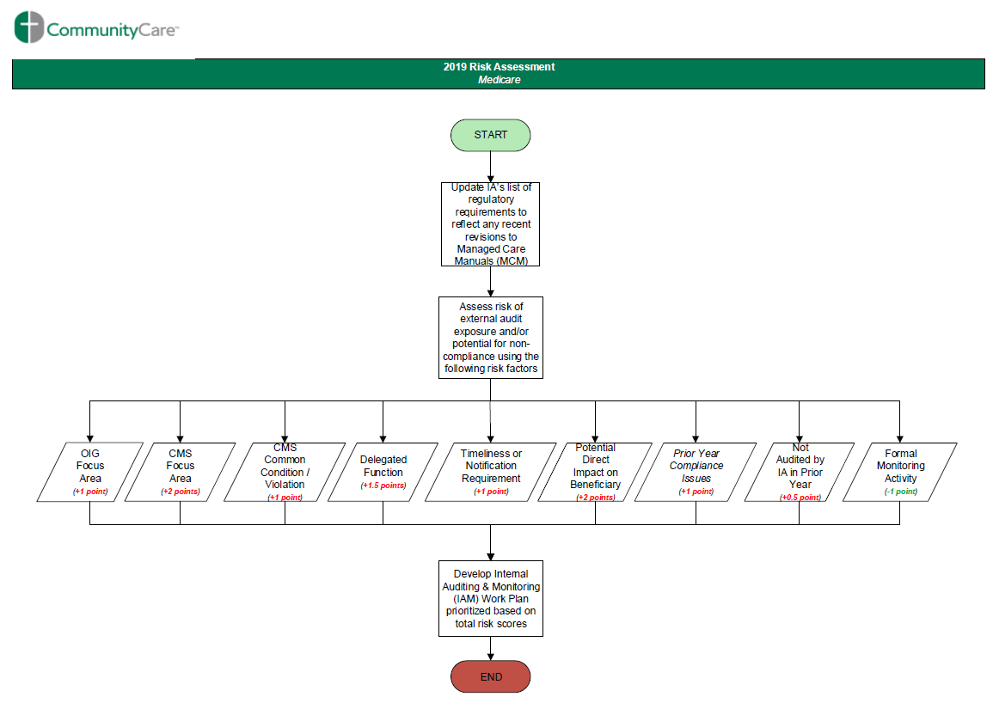

Risk Assessment Totals by Plan
(based on number of measurable functions)
Plan Name | CMS Contract ID | Total Assessed | High | Medium | Low
Senior Health Plan (SHP) | H3755 | 565 | 88 | 181 | 296
Advantage Medicare Plan (AMP | H4198 | 550 | 88 | 177 | 285
Prescription Drug Plan (PDP) | S1894 | 390 | 70 | 116 | 204

Schedule
In order to make the most efficient use of its resources, IA will focus primarily on the highest of the high-risk functions (i.e., those with a total risk score of 9 on a 9-point scale). These functions involve eight (8) measurable requirements, all of which were scored identically on both the AMP and SHP risk assessments. Consequently, the 2019 audit schedule will comprise a total of 23 audits; 8 for AMP, 8 for SHP, and 7 for PDP. Additionally, the 2019 mock audit, including the independent CPE audit will be conducted throughout the year by program area. Please note the first quarter is reserved to complete any outstanding audits from 2018 and coordinate universe submissions for CMS’s annual industry-wide Timeliness Monitoring Project (TMP).

The following chart includes a detailed audit schedule of the 8 measurable requirements as well as the annual mock program audit by program area:

2019 Audit Schedule – Medicare Compliance
Program Area | Manual | Chapter | Sub-Section | Summary of Requirement / Description | Target Quarter for Audit
Mock Audit - FBA | PDBM | Chapter 6 - Part D Drugs and Formulary Requirements | Varies | Annual mock audit of the program areas typically included in a CMS Program Audit (excluding CPE), using applicable CMS Program Audit Protocols. | 2Q
FBA | PDBM | Chapter 6 - Part D Drugs and Formulary Requirements | 30.4.5 - Transition Across Contract Years | After enrollees receive their ANOC in a given year, CMS expects sponsors to select at least one of the two options listed in the referenced section of the guidance for effectuating an appropriate and meaningful transition for enrollees whose drugs will be affected by negative formulary changes in the upcoming year. | 2Q
Mock Audit - CDAG | PDBM | Chapter 18 – Part D Enrollee Grievances, Coverage Determinations, and Appeals | Varies | Annual mock audit of the program areas typically included in a CMS Program Audit (excluding CPE), using applicable CMS Program Audit Protocols. | 3Q
MMG | Medicare Communications and Marketing Guidelines | N/A | 70.1.2 - Documents to be posted on Website | Plans/Part D sponsors must post on their website all required documents outlined below and ensure these documents are downloadable. This includes translated documents, as applicable. | 3Q
Program Area | Manual | Chapter | Sub-Section | Summary of Requirement / Description | Target Quarter for Audit
ODAG | MMCM | Chapter 13 - Medicare Managed Care Beneficiary Grievances, Organization Determinations, and Appeals | 40.1 - Standard Time Frames for Organization Determinations | When an enrollee has made a request for a service, the Medicare health plan must notify the enrollee of its determination as expeditiously as the enrollee’s health condition requires, but no later than 14 calendar days after the date the organization receives the request for a standard organization determination. | 3Q  (SHP and AMP only)
Mock Audit – ODAG | MMCM | Chapter 13 - Medicare Managed Care Beneficiary Grievances, Organization Determinations, and Appeals | Varies | Annual mock audit of the program areas typically included in a CMS Program Audit (excluding CPE), using applicable CMS Program Audit Protocols. | 4Q  (SHP and AMP only)
CDAG | PDBM | Chapter 18 - Part D Enrollee Grievances, Coverage Determinations, and Appeals | 40.4 - Effect of Failure to Provide Timely Notice | If a Part D plan sponsor does not provide notice of its standard coverage determination within the required time frame, it must forward the complete case file to the IRE contracted by CMS within 24 hours of the expiration of the adjudication time frame. | 4Q
CDAG | PDBM | Chapter 18 - Part D Enrollee Grievances, Coverage Determinations, and Appeals | 50.6 - Effect of Failure to Provide Timely Notice | If a Part D plan sponsor does not provide notice of its expedited coverage determination within the required time frame, it must forward the complete case file to the IRE contracted by CMS within 24 hours of the expiration of the adjudication time frame. | 4Q
FBA | PDBM | Chapter 6 - Part D Drugs and Formulary Requirements | 30.4.4 - Transition Timeframes and Transition Supply | Within the first 90 days of coverage under a new plan, plans must provide a transition supply when the beneficiary requests a non-formulary drug. This 90-day timeframe applies to retail,  home infusion, long-term care, and mail-order pharmacies. CMS believes it makes sense to both limit and define the amount of time during which a transition process is applicable. Thus, plans are required to provide a temporary fill anytime during the first 90 days of a beneficiary’s  enrollment in a plan. | 4Q
FBA | PDBM | Chapter 6 - Part D Drugs and Formulary Requirements | 30.4.10 - Transition Notices  (excluding section 30.4.10.1) | A successful transition process is contingent upon informing enrollees and their health care provider about their options for ensuring that enrollees’ medical needs are safely accommodated within a Part D sponsor’s formulary. An enrollee who receives a temporary supply of a non-formulary Part D drug at a network pharmacy might simply assume that, by virtue of filling his or her prescription, that the plan will cover that drug for the remainder of the contract year. | 4Q
Program Area | Manual | Chapter | Sub-Section | Summary of Requirement / Description | Target Quarter for Audit
FBA | PDBM | Chapter 6 - Part D Drugs and Formulary Requirements | 30.4.10.1 - Prescriber Notification of Transition Fills | Part D sponsors must ensure that their transition process includes reasonable efforts to notify prescribers of affected enrollees who receive a transition notice. CMS believes that prescriber notification is a means of further strengthening beneficiary protections when dealing with formulary changes or utilization management protocols for necessary medications, because the prescriber is in the best position to advise the beneficiary of the benefits or risks of switching to a different medication. | 4Q
Mock Audit – CPE | MMCM/PDBM | MMCM Chapter 21 and PDBM Chapter 9 - Compliance Program Guidelines | ALL | Each sponsor must implement an effective compliance program that meets the regulatory requirements set forth at 42 C.F.R. §§422.503(b)(4)(vi) and 423.504(b)(4)(vi).  Note: This audit will be performed by an independent third party. | 4Q

Sample Selection
Regularly scheduled audits will be conducted using a sample size of 30. Mock audits will be conducted using sample sizes as outlined in the CMS Program Audit protocols. As mentioned previously, IA may adjust (i.e., increase or decrease) the sample size as needed.

Commercial / ACA Compliance
The audit work plan for Commercial/ACA compliance applies to non-grandfathered plans sold in the individual, small-group and large-group markets which covers two of the three applicable companies. IA’s scope for audits of commercial compliance is currently focused on Title 45, Subtitle A, Subchapter B, Parts 146, 147, 153 (subparts E, F, G, and H only), 154, 156, and 158. Some regulations in Title 45 also reference regulations outlined in other areas such as, Title 29, which would also be in IA’s scope when auditing a particular requirement.

Risk Assessment
Similar to Medicare compliance, IA took an objective approach to assess the risk of external audit exposure and/or potential of non-compliance for each regulatory requirement. The process started with a current list of in-scope requirements as outlined in the Code of Federal Regulations (CFR). A pre-defined set of risk factors and their associated weights were then applied to each measurable requirement. Below is a summary of the overall process and the results:

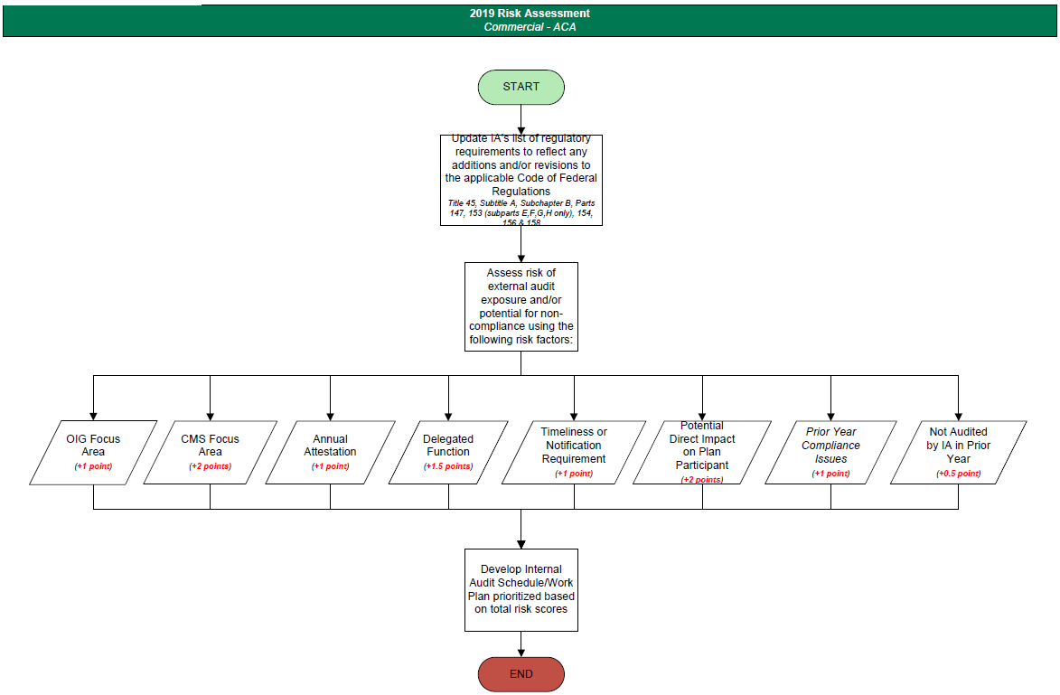

Of the three-hundred twenty-one (321) health insurance issuer standards created, modified, or referenced in the in-scope CFRs, four (4) measurable requirements were assessed as high-risk, one-hundred twenty-six (126) as medium-risk, and one-hundred ninety-one (191) as low-risk.

Risk Assessment Totals
(based on number of measurable requirements)
High | Medium | Low
4 | 126 | 191

Schedule
In order to make the most efficient use of its resources, IA will focus primarily on the four (4) high-risk requirements which comprise a total of twelve (12) operational functions. The 2019 audit schedule will include all 12 operational functions one of which was already scheduled as a re-audit from 2018 to confirm sufficient corrective action was taken in response to audit findings:

2019 Audit Schedule – Commercial Compliance (ACA)
Code of Federal Regulations | Process | Sub-Process | Department | Targeted Quarter for Audit
45 CFR §147.136 (b)  29 CFR §2560.503-1 (f) | Internal Claims Process | Timeliness of Benefit Determinations | Medical Management | 1Q
45 CFR §147.136 (e)  29 CFR §2560.503-1 (g) | Internal Claims Process | Form & Manner of Notifications for Benefit Determinations | Medical Management | 1Q
45 CFR §147.136 (b)  29 CFR §2560.503-1 (f) | Internal Claims Process | Timeliness of Benefit Determinations | Behavioral Health | 2Q
45 CFR §147.136 (e)  29 CFR §2560.503-1 (g) | Internal Claims Process | Form & Manner of Notifications for Benefit Determinations | Behavioral Health | 2Q
45 CFR §147.136 (b)  29 CFR §2560.503-1 (f) | Internal Claims Process | Timeliness of Benefit Determinations | Claims | 2Q
45 CFR §147.136 (e)  29 CFR §2560.503-1 (g) | Internal Claims Process | Form & Manner of Notifications for Benefit Determinations | Claims | 2Q
45 CFR §147.136 (b)  29 CFR §2560.503-1 (i) | Internal Appeals Process | Timeliness of Benefit Determinations on Review | Quality Improvement | 3Q
45 CFR §147.136 (e)  29 CFR §2560.503-1 (j) | Internal Appeals Process | Form & Manner of Notifications for Benefit Determinations on Review | Quality Improvement | 3Q
45 CFR §156.122(c) | Essential Health Benefits Package | Prescription Drug Benefits (Exception Requests) | Pharmacy | 3Q
45 CFR §147.136 (b)  29 CFR §2560.503-1 (f) | Internal Claims Process | Timeliness of Benefit Determinations | Pharmacy | 4Q
45 CFR §147.136 (e)  29 CFR §2560.503-1 (g) | Internal Claims Process | Form & Manner of Notifications for Benefit Determinations | Pharmacy | 4Q
45 CFR §147.106(c)(f)  (Re-Audit) | Guaranteed Renewability of Coverage | Notice of Renewal of Coverage  Discontinuing a Particular Product | Marketing | 4Q

Sample Selection
Audits of ACA rules and regulations will be conducted using a sample size of 30. As mentioned previously, IA may adjust (i.e., increase or decrease) the sample size as needed.

Commercial / URAC Accreditation Compliance
The audit work plan for URAC compliance applies to URAC standards for on-Exchange Qualified Health Plan (QHP) Issuers codified at 45 CFR §156.275. X Organization’s on-Exchange business consists of small groups enrolled through the Small Business Health Options Program (SHOP) offered by both X Organization HMO, Inc. and X Organization Life and Health Insurance Company. IA performed a risk assessment of the universe of URAC standards outlined in the Health Plan with Health Insurance Marketplace Accreditation Guide, Version 7.3.

Risk Assessment
Similar to ACA and Medicare compliance, IA took an objective approach to assess the risk of external audit exposure and/or potential of non-compliance for each requirement. The process started with a current list of in-scope requirements as outlined in the Code of Federal Regulations (CFR). A pre-defined set of risk factors and their associated weights were then applied to each measurable requirement. Below is a summary of the overall process and the results:

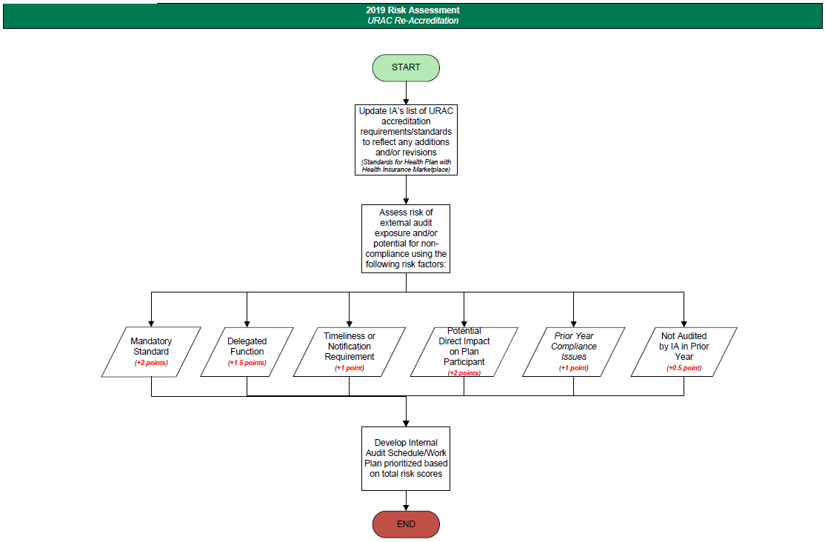

Of the one-hundred fifty-five (155) URAC standards, seven (7) standards were assessed as high-risk, ninety-five (95) as medium-risk, and fifty-three (53) as low-risk.

Risk Assessment Totals
High | Medium | Low
7 | 95 | 53

Schedule
In order to make the most efficient use of its resources, IA will focus on the high-risk functions which comprise a total of seven (7) standards. The 2019 audit schedule will include the seven (7) high-risk standards, one (1) of which was already scheduled as a re-audit from 2018 to confirm sufficient corrective action was taken in response to audit findings. The following table outlines the 2019 URAC Compliance Audit schedule including the targeted quarter for each audit:

2019 Audit Schedule – Commercial Compliance (URAC)
External Reference Number | Process | Sub-Process | Targeted Quarter for Audit
HUM 38  (Re-Audit) | Health Utilization Management | Expedited Appeal Process Time Frame | 1Q
HUM 15 | Health Utilization Management | Drug Utilization Management Reviewer Qualifications | 2Q
HUM 16 | Health Utilization Management | Prospective, Concurrent and Retrospective Drug  Utilization Management | 2Q
OPS 8 | Health Plan Operations | P&T Formulary Development | 3Q
OPS 9 | Health Plan Operations | P&T Committee Membership | 3Q
OPS 10 | Health Plan Operations | Economic Formulary Considerations | 4Q
OPS 11 | Health Plan Operations | Oversight of Automated Review of Pharmacy Non-Certifications | 4Q

Sample Selection
Audits of URAC standards will be conducted using a sample size of 30. As mentioned previously, IA may adjust (i.e., increase or decrease) the sample size as needed.

MONITORING ACTIVITIES

Scope
Internal monitoring consists of activities performed as part of a department’s normal operations, or which are delegated to a third party, to confirm ongoing regulatory compliance and to ensure actions taken to correct and/or prevent issues are effective. The current focus (i.e., formal oversight) includes activities related to compliance with Medicare rules and regulations. These monitoring activities also includes those performed to identify and remediate potential fraud, waste or abuse, as defined by CMS.

Schedule

Compliance with Medicare rules and regulations are monitored closely within all operational areas throughout the company. Each process owner is required to report (i.e., attest) whether any compliance issues were identified during their respective monitoring activities. Attestations occur in the same frequency as the monitoring activity itself which involves providing evidence of the activity and relevant information in accordance with CMS Program Audit Protocols. The following chart provides a detailed schedule of the Medicare monitoring activities for each operational area. Refer to the ‘Process Owner Attestation’ in this document for the attestation schedule.

2019 MEDICARE MONITORING SCHEDULE BY DEPARTMENT
Type of Monitoring | Department | Name of Component / Operation | Description of Monitoring Activity | Control / Monitoring Frequency
Internal Operations | Behavioral Health | Denial Notices | Verify denial notices are timely, accurate and contain sufficient detail to explain the reason for denial. | Monthly
Internal Operations | Behavioral Health | Organization Determinations | Confirm that pre-service authorization requests have been processed in a timely manner. | Monthly
Internal Operations | Behavioral Health | Provider Outreach | Verify sufficient outreach to providers or enrollees was performed to obtain additional information necessary to make appropriate clinical decisions. | Monthly
Internal Operations | Claims | Contracted Provider Claims | Ensure contracted provider claims are being processed timely. | Weekly
Internal Operations | Claims | Member Denial Letters | Denial notices are timely, accurate and contain sufficient detail to explain the reason for denial. | Weekly
Internal Operations | Claims | Member Reimbursements | DMR requests are processed timely and accurately. | Weekly
Internal Operations | Claims | MSP vs MMR Reconciliation | Review the MSP vs MMR files provided by DAR monthly to verify if claims were paid properly based on the information in our system. Any discrepancies are verified by the COB Specialist and refunds requested as necessary. | Monthly
Internal Operations | Claims | Non-Contracted Provider Claims | Non-contracted provider claims are processed timely. | Weekly
Internal Operations (FWA Activity) | Claims | OIG/GSA Exclusions | Review monthly reports from Data Analysis & Reporting and request refunds for all non-emergent claims paid to excluded providers and all non- urgent and emergent claims paid to opted out providers. | Monthly
Internal Operations | Claims | Provider Waiver of Liability Letters | Denial notices contain a copy of the Waiver of Liability form or a link to the form. | Weekly
Internal Operations | Compliance | Annual CPE Audit | The annual Medicare CPE audit is conducted by an independent party, and the audit results are shared with the governing body. | Annually – Dec
Internal Operations | Compliance | Board Oversight | Results of internal monitoring activities related to Medicare are reported in summary fashion to the Board at least annually. | Annually - Dec
Type of Monitoring | Department | Name of Component / Operation | Description of Monitoring Activity | Control / Monitoring Frequency
Internal Operations | Compliance | Compliance Committee Oversight | Issues, findings or deficiencies identified through internal monitoring activities, along with their related corrective actions, are reviewed by the Medicare Committee at least monthly. The Compliance Committee reviews recommendations made by the Medicare Committee and requires revisions, if necessary. | Monthly
Internal Operations (FWA Activity) | Compliance | Hotline Calls | Check the Compliance Hotline for messages and track reports of suspected non-compliance or FWA. | Daily
First Tier Entity Operations  (FWA Activity) | Compliance | MEDIC Investigations and Fraud Alerts | Provide responsive data to NBI MEDIC following receipt of claim information from Pharmacy Services, Quality Improvement and/or Data Analysis & Reporting department(s). | Incident/  Event-Based
Internal Operations (FWA Activity) | Compliance | OIG/GSA Exclusions | Review monthly exclusion reports from Data Analysis & Reporting to confirm that no active vendors have been excluded from participation in federal health care programs. | Monthly
Internal Operations | Configuration | Benefit Plan Build | Changes to benefits are reviewed for accuracy. | Annually - Feb
Internal Operations | Configuration | Fee Schedules | Fee schedule uploads are reviewed for accuracy. | Incident/  Event-Based
Internal Operations (FWA Activity) | Configuration | OIG/GSA Exclusions | Review monthly reports from Data Analysis & Reporting to confirm that excluded/opted out providers in our system are set to deny for claims with dates of service during the exclusion period. | Monthly
Internal Operations | Configuration | Provider Affiliation Load | Changes to contracted and non-contracted provider records are reviewed for accuracy. | Daily
Internal Operations | Customer Service | Misclassified Grievances & Organization Determinations | Review calls to ensure grievances and organization determinations are properly identified. | Daily
Internal Operations | Customer Service | Phone Stats | Verify incoming calls are answered timely and within accepted abandonment rate. | Daily
Internal Operations | Enrollment | Creditable Coverage | LEP confirmations to CMS and notices to members are made in a timely manner. | Monthly
Internal Operations | Enrollment | Enrollment Timeliness | Enrollment applications are processed in a timely manner. | Monthly
Internal Operations | Enrollment | Late Payer Notices | Verify late payer notices were accurate and mailed to members in a timely manner. | Monthly
Internal Operations | Enrollment | MSP Review/Update | Review 10% of MSP records to ensure they were processed correctly, including updates to CMS' Electronic Correspondence Referral System (ECRS) as necessary. | Monthly
Internal Operations | Enrollment | OEV Process | Verify required OEV procedures are followed according to Medicare requirements. | Daily
Internal Operations | Enrollment | TRR Processing/Letters | Updates to member records per TRR are accurate and any applicable notices to members are provided in a timely manner. | Daily
Internal Operations | Finance | Premium Refunds | Premiums are refunded to termed members in a timely manner. | Monthly
Internal Operations | Human Resources | ComplianceWire Training | Ensure Medicare compliance training is completed by employees in a timely manner. | Weekly
Type of Monitoring | Department | Name of Component / Operation | Description of Monitoring Activity | Control / Monitoring Frequency
Internal Operations (FWA Activity) | Human Resources | OIG/GSA Exclusions | Review monthly exclusion reports from Data Analysis & Reporting to confirm that no employees have been excluded from participation in federal health care programs. | Monthly
Internal Operations | Marketing | Retiree Group Benefit Materials | Ensure benefit materials are accurate and delivered to retiree groups in a timely manner.  (applicable to Senior Health Plan only) | Annually - Oct
Internal Operations | Medical Management | Denial Notices | Verify denial notices are timely, accurate and contain sufficient detail to explain the reason for denial. | Daily
Internal Operations | Medical Management | Organization Determinations | Verify a sample of organization determinations are processed and communicated in accordance with Medicare requirements. | Monthly
Internal Operations | Medical Management | Provider Outreach | Verify sufficient outreach to providers or enrollees was performed to obtain additional information necessary to make appropriate clinical decisions. | Weekly
First Tier Entity Operations  (FWA Activity) | Pharmacy | CMS Pharmacy Risk Assessment | Review report from PBM comparing CMS quarterly Pharmacy Risk Assessment report to PBM's participating pharmacy network to ensure PBM has identified participating high-risk pharmacies and taken appropriate compliance action. | Quarterly
Internal Operations | Pharmacy | Denial Notice Content | Reviews all denial letters for Part D coverage determinations prior to mailing to ensure denial language is accurate, complete, and in accordance with CMS guidelines. | Daily
First Tier Entity Operations | Pharmacy | Drugs in LTC Setting | Reviews the Part D NDA/BLA paid claims report to identify drugs dispensed in an LTC setting with greater than a 14-day supply. Any coding issues are resolved with the PBM. | Weekly
First Tier Entity Operations | Pharmacy | FDR Compliance Review | Obtain written assurance from FDR that annual FWA and general compliance training, OIG/GSA exclusion, and compliance program and policy requirements have been satisfied. | Annually - Dec
Internal Operations | Pharmacy | Misclassified Grievances & Coverage Determinations | Review a sample of calls to ensure grievances and coverage determinations are properly identified. | Daily
Internal Operations (FWA Activity) | Pharmacy | Out-of-State Diabetic Testing Supplies | Identify paid claims from pharmacies outside of Oklahoma where diabetic supplies were filled. Coordinate member and provider outreach with the Pharmacy Help Desk to determine if Fraud, Waste, or Abuse occurred in the selected claims data. | Incident/  Event-Based
First Tier Entity Operations | Pharmacy | Paid/Rejected Claim Review | Pharmacy paid and rejected claims are validated on a daily basis to confirm that adjudication at point of sale was in compliance with the approved formulary FRF file. | Daily
First Tier Entity Operations | Pharmacy | PBM Call Log Review | Verify calls received by the Pharmacy Benefit Manager (PBM) related to a grievance or coverage determination were transferred to X Organization for processing. | Daily
First Tier Entity Operations | Pharmacy | PDE Reconciliation | Review rejections of PDE submitted to CMS by our PBM and assist with reconciliation of errors. | Monthly
Internal Operations | Pharmacy | Pharmacy Authorization Review | Verify required procedures are followed when processing coverage determinations and exceptions. | Daily
First Tier Entity Operations  (FWA Activity) | Pharmacy | Pharmacy Network FWA | PBM reviews Pharmacy Membership Evaluation Committee (PMEC) and/or Network Provider Evaluation Committee (NPEC) report and takes appropriate compliance action relative to pharmacy network providers. | Monthly
Internal Operations | Provider Services | ADI Accreditation (Annual) | ADI accreditation certifications for participating providers have not expired. | Annually - Aug
Internal Operations | Provider Services | ADI Accreditation (Claims) | ADI accreditation certifications are verified for providers with pended claims. | Incident/  Event-Based
Internal Operations | Provider Services | Beneficiary Protections | Medicare members are notified of provider terminations in a timely manner. | Weekly
Type of Monitoring | Department | Name of Component / Operation | Description of Monitoring Activity | Control / Monitoring Frequency
Internal Operations (FWA Activity) | Provider Services | FWA Provider Training | Ensure annual notice is sent to participating providers to complete annual FWA training and OIG/GSA exclusion list monitoring. | Annually - Jul
Internal Operations | Provider Services | Network Adequacy (Complaints) | Review of member complaint logs regarding provider network access. | Quarterly
Internal Operations | Provider Services | Network Adequacy  (HSD Tables) | Verify provider and facility specialties and network adequacy criteria relating to minimum number of providers/facility, maximum travel time, and maximum travel distance. | Quarterly
Internal Operations (FWA Activity) | Provider Services | OIG/GSA Exclusions | Review monthly exclusion reports from Data Analysis & Reporting to confirm that no credentialed providers contracted for Medicare lines of business have been excluded from participation in federal health care programs. | Monthly
Internal Operations | Provider Services | Provider Contracts (Templates) | Ensure provider contract templates contain required provisions. | Incident/  Event-Based
Internal Operations | Provider Services | Provider Directory Accuracy | Confirm that changes received from providers are properly entered into the system to ensure accurate provider directory. | Quarterly
Internal Operations (FWA Activity) | Provider Services | Provider Enrollment Validation | Compare Medicare contracted practitioners to the CMS PECOS & enrollment files to verify enrollment with Medicare. | Semi-Annual
Internal Operations | Quality Improvement | Anti-Discrimination Reportline | Check the Anti-Discrimination Reportline for messages and track reports of suspected discrimination related to Medicare beneficiaries. | Daily
First Tier Entity Operations | Quality Improvement | Data Validation  (MTM Program) | All reporting elements required in CMS memo were validated for accuracy and timeliness. | Annually - Feb
Internal Operations | Quality Improvement | Part C Data Validation (Appeals) | Verify accuracy of Part C appeals data before submission by Compliance Officer to CMS. | Annually - Feb
Internal Operations | Quality Improvement | Part C Grievance & Appeals | Verify Part C grievances and appeals are processed accurately and in a timely manner. | Quarterly
Internal Operations | Quality Improvement | Part C QOC Complaint Categorization | Review Part C quality of care (QOC) complaints received from Medicare beneficiaries and ensure they are categorized appropriately. | Daily
Internal Operations | Quality Improvement | Part D Data Validation (Appeals) | Verify accuracy of Part D appeals data before submission by Compliance Officer to CMS. | Annually - Feb
Internal Operations | Quality Improvement | Part D Grievance & Appeals | Verify Part D grievances and appeals are processed accurately and in a timely manner. | Quarterly
Internal Operations | Quality Improvement | Part D QOC Complaint Categorization | Review Part D quality of care (QOC) complaints received from Medicare beneficiaries and ensure they are categorized appropriately | Daily
First Tier Entity Operations  (FWA Activity) | Quality Improvement | Provider on Review | Prepayment medical record review of claims submitted by providers placed on review for suspected FWA. | Daily
First Tier Entity Operations  (FWA Activity) | Quality Improvement | Specific CPT/HCPCS Codes | Prepayment review of claims with specified CPT/HCPCS codes identified as higher risk of FWA. | Quarterly

PROCESS OWNER ATTESTATION
Scope
Process owners will be required to complete periodic attestations for their respective control (i.e., monitoring) activities. The attestation process includes attesting whether the control is implemented and operating as intended, providing evidence of the activity (if applicable), and documenting information related to any issues identified and remediation tasks (i.e., corrective/preventive actions) completed.
Schedule
Attestations will be performed in accordance with the below schedule:
Attestation Schedule
Control Category | Control Frequency | Attestation Frequency | Attestation Due Date
MAR Entity-Level Controls | Annually | Annually | November 30th
MAR Internal Controls | Varies | Annually | April 30th
Medicare Monitoring Activities | Daily | Monthly | Last day of following month
 | Weekly | Weekly | Last day of following week
 | Monthly | Monthly | Last day of following month
 | Quarterly | Quarterly | February 15th  May 15th  August 15th  November 15th
 | Semi-Annual | Semi-Annual | June 30th  December 31st
 | Annually - Feb | Annually | February 28th
 | Annually – Jul | Annually | July 31st
 | Annually – Aug | Annually | August 31st
 | Annually – Oct | Annually | October 31st
 | Annually - Dec | Annually | December 31st

DOCUMENTATION & REPORTING

Audit Activities

IA will retain work paper documentation of all auditing activities, including control testing, electronically. Audit work papers will contain sufficient information to support the auditor’s assessment. Audit results will be communicated to the process owner and appropriate department management. IA will also prepare executive summary reports that reflect the overall results and any recommendations. The Internal Audit Committee (IAC) will review all draft audit reports prior to dissemination to the company’s Executive Leadership Team (ELT), which also functions as the company’s corporate Compliance Committee. IA will request a corrective action plan (CAP) from process owners to address deficiencies, exceptions and/or incidental findings. The IAC will review each CAP to ensure sufficient actions have been developed and implemented to address the findings. Results will be reported in summary fashion to the Audit & Compliance Committee of the Board.

Monitoring Activities

As mentioned previously, process owners will be required to complete periodic attestations for their respective monitoring activities, which include providing evidence of the activity as well as information related to any compliance issues that were identified. Issues, findings or deficiencies identified through internal monitoring activities, along with their related corrective actions, will be reported to the plan's Medicare Committee at least monthly. The Medicare Committee will review the sufficiency of corrective action plans and make recommendations to the Compliance Committee. The Compliance Committee will review the Medicare Committee's recommendations, and may require that corrective action plans be revised. Results of internal monitoring activities will also be reported in summary fashion to the Board.

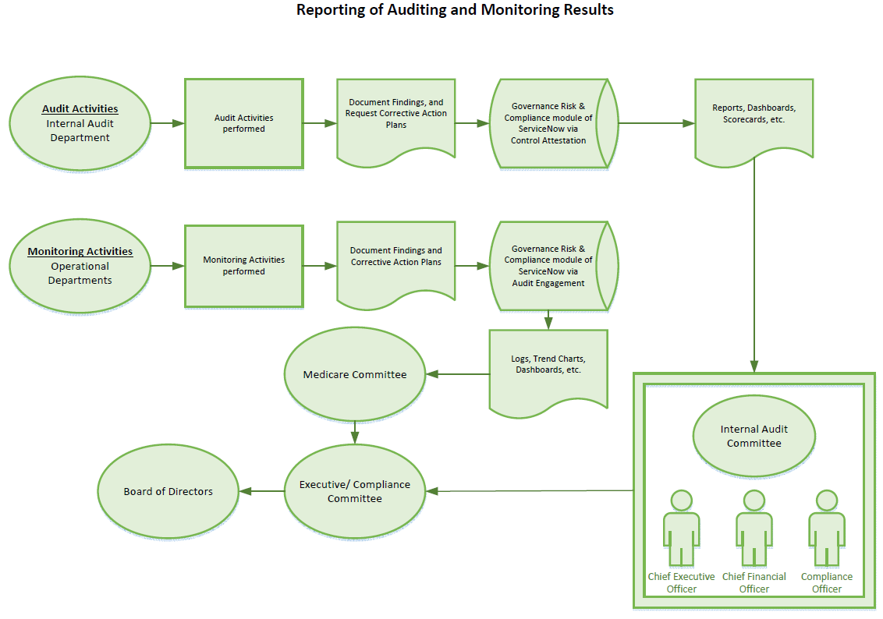
Amendments: This audit work plan may be modified to reflect changes in applicable law or regulatory guidance, as well as changes in the company’s compliance needs. The audit work plan may also be revised to reflect changes in scheduling, methodology, or auditing tools, subject to prior approval by the Internal Audit Committee.

Refer to the Monitoring Activity section for more information related to the evaluation (i.e., attestation) performed by process owners.
IA will also use this time to work on action items from KPMG’s recommendations during phase II of the 2018 MAR Optimization project.
Stratified sampling will be used to ensure data from both quarters are represented. The timeframe will also be adjusted for any corrective action plans in process during the period of review.

