**PRIVILEGED & CONFIDENTIAL**

**TO:** The Governance Committeeof the Board of Directors of ABC Hospitals

**FROM:** John Smith – Chief Compliance Officer

**DATE:** February 27, 2018

**RE:** Compliance Report for the quarter ended December 31, 2017

This Compliance Report is to the Governance Committee of the Board of Directors of ABC Hospitals. Please treat this report as a confidential document not for further disclosure or distribution.

**SECTION I: Compliance Program Activities and Goals**

1. **Activities this Quarter:**

**Hospital A**

* Reviewed the

**Hospital B**

* Continued to implement processes and completed tasks

**Hospital C**

* Continued to work with management

1. **Quarterly Statistics**

**Compliance and privacy cases opened and closed during the last quarter**

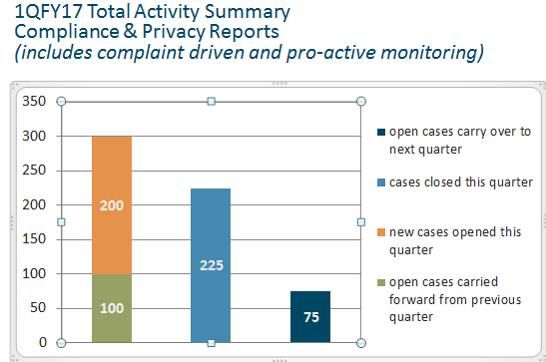

**Results of closed compliance cases**

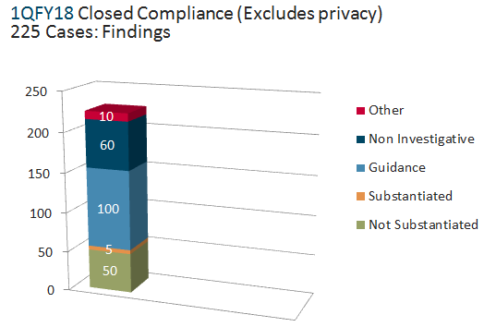

**Disciplinary Action Taken**

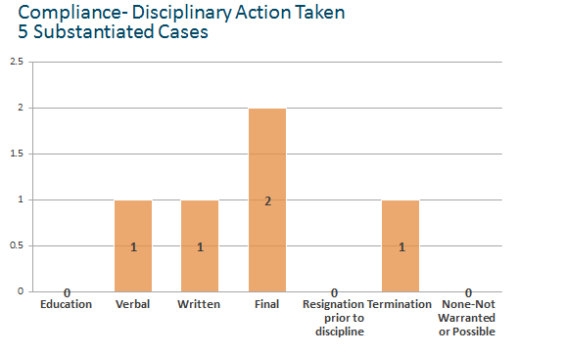

**Privacy Activity**

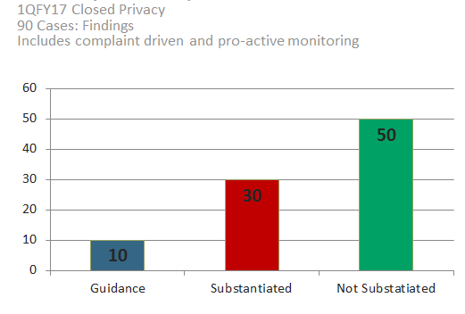

**Results of closed privacy cases**

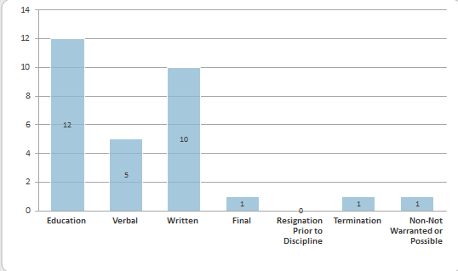

1. **Goals for upcoming Quarter:**

**Hospital A**

* Implement signage
* Prioritize
* Finalize review

**Hospital B**

* Continue investigation of

**SECTION III: Investigations with Government Agency Involvement**

**Hospital A**

* CMS requested records of 10 IP 1 day stays.

**SECTION IV: Internal Investigations/Review**

**Hospital A**

**Section V. Internal Education, Auditing and Monitoring Activities**

**ABC Hospitals Audit Plan**

The following audits were completed between 10/1/17 and 12/31/17:

|  |  |  |
| --- | --- | --- |
| **Location** | **Description** | **Restitution** |
| Hospital A | Review of coding to validate  **Audit to validate correct coding.** | None |
| Hospital C | Review of DRG  .  **Audit to validate correct documentation.** | None |

**Section VI. HIPAA Privacy Compliance Activity**

**Office for Civil Rights (OCR) Investigations:**

**Hospital A**

Patient complaint was made claiming

***February 2018 Update:*** Still pending.

**HIPAA-related Hotline Calls**

|  |  |  |  |
| --- | --- | --- | --- |
| **Hospital** | **# of Substantiated** | **# of Unsubstantiated** | **Total** |
| A | 1 | 12 | 13 |
| B | 3 | 0 | 3 |
| C | 0 | 2 | 2 |
| **Total** | **4** | **14** | **18** |

**Other Significant Privacy Matters**

**Section VII. Recovery Auditor Update**

**26**

**26**

**5**

**5**

**8**

**5**

None

|  |  |  |  |  |  |  |  |  |
| --- | --- | --- | --- | --- | --- | --- | --- | --- |
| **Region** | **Status** | **Count** | **Original Payment Payer 1** | **Audit Assigned Payment 1** | **Payment Variance 1** | **Recouped Amount 1** | **Repayment Amount 1** | **Resolved Amount 1** |
| **A** | **FAVORABLE** | 52 | $XX,XXX | $XX,XXX | $X,XXX | $X,XXX | $XX,XXX | $X,XXX |
| **PENDING - APPEAL** |  |  |  |  |  |  |  |
| **PENDING – NO 1ST LEVEL APPEAL** |  |  |  |  |  |  |  |
| **UNFAVORABLE** |  |  |  |  |  |  |  |
| **SETTLEMENT** |  |  |  |  |  |  |  |
| **A TOTALS** |  |  |  |  |  |  |  |
| **B** | **FAVORABLE** |  |  |  |  |  |  |  |
| **PENDING - APPEAL** |  |  |  |  |  |  |  |
| **PENDING – NO 1ST LEVEL APPEAL** |  |  |  |  |  |  |  |
| **UNFAVORABLE** |  |  |  |  |  |  |  |
| **SETTLEMENT** |  |  |  |  |  |  |  |
| **B TOTALS** |  |  |  |  |  |  |  |
| **C** | **FAVORABLE** |  |  |  |  |  |  |  |
| **PENDING - APPEAL** |  |  |  |  |  |  |  |
| **PENDING – NO 1ST LEVEL APPEAL** |  |  |  |  |  |  |  |
| **UNFAVORABLE** |  |  |  |  |  |  |  |
| **SETTLEMENT** |  |  |  |  |  |  |  |
| **C TOTALS** |  |  |  |  |  |  |  |
| **TOTAL** | **FAVORABLE** |  |  |  |  |  |  |  |
| **PENDING - APPEAL** |  |  |  |  |  |  |  |
| **PENDING – NO 1ST LEVEL APPEAL** |  |  |  |  |  |  |  |
| **UNFAVORABLE** |  |  |  |  |  |  |  |
| **SETTLEMENT** |  |  |  |  |  |  |  |
| **TOTALS** |  |  |  |  |  |  |  |

**CMS Recovery Auditor Update**

APPENDIX A – LISTING OF EDUCATIONAL ACTIVITIES

|  |  |  |  |
| --- | --- | --- | --- |
| **Hospital** | **Type of Training** | **Department** | **Type of Training** |
| A | New Co-Worker Compliance & Privacy Education | Compliance | In person |
| A | Coding | Coding | Webinar |

APPENDIX B – COMPLIANCE DEPARTMENT STAFFING UPDATE

Privacy Manager Position, Hospital C, City, State

Compliance Assistant, Hospital A, City, State